Department of Computer Science and Engineering

Assignment Questions

Course Code & Name: CSA0615 –Design and Analysis of Algorithms
Particular | Details
Department: | INFROMATION TECHONOLOGY
Programme: | B. TECH IT
Course Code & Course Name | CSA0621 - Design and Analysis of Algorithms
Academic Year / Batch | 2nd year
Faculty Name | Dr G Nagarajan
Assignment Title | Development of an Efficient Algorithmic Solution for Large-Scale Data Processing
Date of Issue
Date of Submission
Maximum Marks | 100
Course Outcome(s) – CO | CO1: Analyse the efficiency of recursive and non-recursive algorithms using asymptotic notations (Big-O, Ω, Θ) and complexity-analysis methods such as the master theorem, substitution, and iteration.  CO2: Apply brute-force techniques such as sorting and searching to solve computational problems.  CO3: Apply divide-and-conquer techniques to design efficient algorithmic solutions.
Bloom's Taxonomy Level | L4 – Analyse; L5 – Evaluate; L6 – Create
SDG Mapping (SDG 1-17) | SDG 9 – Industry, Innovation and Infrastructure
Industry / Societal Relevance | Smart Infrastructure Planning and Geospatial Data Optimization

Assignment Problem / Challenge
The assignment should preferably require students to:

  - Apply course concepts rather than reproduce theory.
  - Identify and analyze the problem.
  - Consider requirements and constraints.
  - Develop or compare alternative solutions where appropriate.
  - Use relevant modern engineering/computing/design tools.Interpret results.
  - Make and justify engineering decisions.
  - Consider appropriate technical, economic, environmental, societal, ethical, safety or sustainability factors wherever relevant.

Problem Statement
An infrastructure-planning agency maintains a large, publicly available geospatial dataset of facility locations — for example, the OpenFlights airports dataset (~40,000 points) or a cell-tower / weather-station dataset containing 10⁴–10⁶ coordinate records. To detect redundant or dangerously close facilities and to optimise service coverage, the agency must identify the closest pair of locations — the two points separated by the minimum Euclidean distance in the dataset. Develop, implement, and evaluate a solution to this Closest-Pair-of-Points problem. Implement (i) a Brute-Force algorithm that evaluates all n(n−1)/2 pairs, of order O(n²), and (ii) a Divide-and-Conquer algorithm that recursively partitions the point set about the median x-coordinate and merges across the dividing strip, of order O(n log n) ; then develop an optimised hybrid that reverts to brute force below a threshold sub-problem size. Analyse the theoretical efficiency of each approach using Big-O, Ω, and Θ notations, solving the recurrence T(n) = 2T(n/2) + O(n) by the master theorem. Experimentally evaluate all three algorithms on the chosen dataset across increasing input sizes (for example, 10³ to 10⁶ points), measuring execution time, number of distance computations/comparisons, memory utilisation, and scalability. Based on the theoretical and experimental results, optimise the solution and justify why the proposed hybrid is most suitable for large-scale infrastructure data — reflecting Bloom’s Levels 4–6 (Analyse, Evaluate, Create) and contributing to SDG 9 (Industry, Innovation and Infrastructure).

Requirements and Constraints
Use a publicly available real-world coordinate dataset with enough records to test multiple input sizes (10³–10⁶ points). All three algorithms (brute force, divide-and-conquer, hybrid) must be run in the same computational environment for a fair comparison, on identical inputs. Report both empirical timings and operation counts, and clearly document the threshold chosen for the hybrid, along with all assumptions and limitations.

Student Work

Problem Statement and Problem Formulation
1.1 Problem Statement
An infrastructure-planning agency maintains a large geospatial dataset containing the locations of facilities such as airports, cell towers, weather stations, emergency service centres, or other infrastructure facilities. Each facility is represented as a point using its geographical coordinates.
As the number of facilities increases, it becomes important to identify facilities that are located extremely close to one another. Two facilities that are unnecessarily close may represent redundant infrastructure, overlapping service coverage, or potential planning and safety concerns.
The objective of this project is to solve the Closest-Pair-of-Points Problem, in which the two points having the minimum Euclidean distance among all points in a dataset must be identified.
The assignment requires three algorithmic approaches:
Brute-Force Algorithm – compares every possible pair of points.
Divide-and-Conquer Algorithm – recursively divides the points according to their x-coordinates and efficiently searches across the dividing region.
Hybrid Algorithm – combines divide-and-conquer with brute force for small sub-problems.
The three approaches must be implemented and evaluated using the same computational environment and identical inputs. Their execution time, number of distance computations/comparisons, memory utilisation, and scalability are then compared. These requirements are explicitly specified in the assignment.

1.2 Problem Formulation
Let the input dataset contain:
$$P=\left\{p_{1} , p_{2} , p_{3} , … , p_{n}\right\}$$
where each point is represented as:
$$p_{i}=\left(x_{i} , y_{i}\right)$$
The Euclidean distance between two points $p_{i}=\left(x_{i} , y_{i}\right)$and $p_{j}=\left(x_{j} , y_{j}\right)$is:
$$d\left(p_{i} , p_{j}\right)=\sqrt{{\left(x_{i}-x_{j}\right)}^{2}+{\left(y_{i}-y_{j}\right)}^{2}}$$
The objective is to find:
$$d_{min}=\min_{1≤i<j≤n}d\left(p_{i} , p_{j}\right)$$
and return the corresponding pair of points.
For the brute-force approach, all possible pairs are examined. The number of pairs is:
$$\frac{n\left(n-1\right)}{2}$$
Therefore, its time complexity is:
$$O\left(n^{2}\right)$$
The divide-and-conquer approach recursively divides the point set around the median x-coordinate and examines only the relevant points near the dividing line. Its recurrence is:
$$T\left(n\right)=2T\left(n/2\right)+O\left(n\right)$$
Using the Master Theorem:
$$T\left(n\right)=O\left(n\log{n}\right)$$
The hybrid approach applies divide-and-conquer for large sub-problems but switches to brute force when the number of points becomes smaller than a selected threshold.

Objective and Expected Outcomes

2.1 Objectives
The main objectives of this project are:
To understand and formulate the Closest-Pair-of-Points problem.
To implement a brute-force solution for finding the closest pair.
To implement a divide-and-conquer solution for the same problem.
To develop an optimized hybrid solution combining both techniques.
To analyse the theoretical complexity of all three algorithms using Big-O, Ω, and Θ notation.
To solve the recurrence
$$T\left(n\right)=2T\left(n/2\right)+O\left(n\right)$$
using the Master Theorem.
7. To evaluate the algorithms using increasing dataset sizes.
8. To measure execution time and distance computations.
9. To compare the scalability of the three approaches.
10. To determine a suitable threshold for the hybrid algorithm.
11. To identify the most appropriate approach for large-scale infrastructure data.
12. To relate the solution to SDG 9 – Industry, Innovation and Infrastructure.
The assignment specifically expects theoretical and experimental evaluation of the three algorithms and justification of the final solution.

2.2 Expected Outcomes

After completing the project, the following outcomes are expected:
The closest two geographical points can be identified correctly.
The brute-force algorithm should produce correct results but become increasingly expensive as $n$increases.
The divide-and-conquer algorithm should demonstrate better scalability for large datasets.
The hybrid algorithm should reduce unnecessary recursive overhead for small sub-problems.
The experimental results should demonstrate the difference between $O\left(n^{2}\right)$and $O\left(n\log{n}\right)$approaches.
The hybrid algorithm should provide a practical balance between theoretical efficiency and implementation overhead.
The final recommendation should be supported by experimental evidence rather than theoretical complexity alone.

Requirements, Constraints and Assumptions

3.1 Requirements

The following requirements are considered for the implementation.
Functional Requirements
The program shall accept a collection of two-dimensional coordinate points.
The program shall calculate the minimum Euclidean distance.
The program shall identify the two points forming the closest pair.
The program shall implement the brute-force algorithm.
The program shall implement the divide-and-conquer algorithm.
The program shall implement the hybrid algorithm.
The program shall record the execution time of each algorithm.
The program shall count distance calculations/comparisons.
The program shall test multiple input sizes.
The program shall compare the results produced by all three algorithms.
Experimental Requirements
The assignment requires a publicly available real-world coordinate dataset with enough records for testing multiple input sizes, potentially from ${10}^{3}$to ${10}^{6}$points. All algorithms should use identical inputs and the same computational environment for a fair comparison.

3.2 Constraints
The major constraints are:
1. Computational Complexity
The brute-force method performs:
$$\frac{n\left(n-1\right)}{2}$$
comparisons.
For very large $n$, this results in a very high number of operations.
2. Memory
Large datasets require sufficient memory to store coordinate records and intermediate structures.
3. Dataset Size
The selected dataset should contain sufficient records to demonstrate scalability across increasing input sizes.
4. Fair Comparison
All three algorithms must be executed using:
the same computer/environment,
identical input data,
the same coordinate representation,
comparable measurement conditions.
5. Hybrid Threshold
The hybrid algorithm requires a threshold value that determines when recursive divide-and-conquer should stop and brute force should be used.
The assignment requires this threshold to be clearly documented.

3.3 Assumptions

The following assumptions are made:
Each facility is represented by a two-dimensional coordinate.
The input contains at least two valid points.
Coordinate values are numerical.
Duplicate points may exist and are treated as having a distance of zero.
Euclidean distance is used as specified in the problem.
Input points are assumed to represent locations in a coordinate system suitable for the experiment.
Missing or invalid coordinate records are excluded during preprocessing.
The same dataset subset is supplied to all three algorithms during each experiment.
Execution time can vary because of operating-system and background-process activity.
The hybrid threshold is selected experimentally rather than assuming that one threshold is universally optimal.

Application of Relevant Course Knowledge

This project applies several concepts from Design and Analysis of Algorithms.
4.1 Brute-Force Technique

The brute-force method directly evaluates every possible pair of points.
For $n$points:
$$\text{Number of pairs}=\frac{n\left(n-1\right)}{2}$$
Therefore:
$$T\left(n\right)=Θ\left(n^{2}\right)$$
This method is simple and useful as a correctness reference, but its scalability is poor for large datasets.

4.2 Divide-and-Conquer

The main optimization uses the divide-and-conquer paradigm.
The point set is divided into two approximately equal parts according to the median x-coordinate:
$$P_{L} \text{and} P_{R}$$
The closest pair is found recursively in both halves. A narrow strip around the dividing line is then examined to determine whether a pair crossing the division has a smaller distance.
The recurrence is:
$$T\left(n\right)=2T\left(n/2\right)+O\left(n\right)$$
Applying the Master Theorem:
$$a=2, b=2, f\left(n\right)=O\left(n\right)$$
Since:
$$n^{\log_{b}a}=n^{\log_{2}2}=n$$
we obtain:
$$T\left(n\right)=Θ\left(n\log{n}\right)$$
This is significantly more scalable than the brute-force method.

4.3 Asymptotic Analysis

The project applies three major asymptotic notations:
Algorithm | Best/Typical Growth Consideration | Overall Complexity
Brute Force | Pair comparisons grow quadratically | $$Θ\left(n^{2}\right)$$
Divide-and-Conquer | Recursive division + linear merge/strip processing | $$Θ\left(n\log{n}\right)$$
Hybrid | Depends on threshold; approaches divide-and-conquer for large $n$ | Approximately $Θ\left(n\log{n}\right)$
Big-O
Big-O provides an upper bound on the growth of an algorithm.
For brute force:
$$O\left(n^{2}\right)$$
For divide-and-conquer:
$$O\left(n\log{n}\right)$$
Ω (Omega)
Omega represents a lower bound.
The brute-force algorithm must inspect the possible pairs in the general formulation, giving:
$$Ω\left(n^{2}\right)$$
for the straightforward implementation.
Θ (Theta)
Theta gives a tight asymptotic bound.
For the brute-force implementation:
$$Θ\left(n^{2}\right)$$
For the standard divide-and-conquer solution:
$$Θ\left(n\log{n}\right)$$

4.4 Master Theorem
The divide-and-conquer algorithm follows:
$$T\left(n\right)=2T\left(n/2\right)+O\left(n\right)$$
Using the Master Theorem:
$$T\left(n\right)=aT\left(n/b\right)+f\left(n\right)$$
where:
$$a=2, b=2, f\left(n\right)=O\left(n\right)$$
Calculate:
$$n^{\log_{b}a}=n^{\log_{2}2}=n$$
Since:
$$f\left(n\right)=Θ\left(n\right)$$
the recurrence belongs to the corresponding balanced case of the Master Theorem.
Therefore:
$$\boxed{T\left(n\right)=Θ\left(n\log{n}\right)}$$

4.5 Hybrid Algorithm
The hybrid method combines two algorithmic strategies.
For a sufficiently large sub-problem:
$$\text{Use Divide-and-Conquer}$$
When:
$$n≤k$$
where $k$is the selected threshold:
$$\text{Use Brute Force}$$
This is useful because recursion and repeated partitioning can introduce overhead when the number of points becomes very small.
Therefore, the hybrid algorithm attempts to obtain:
the scalability of divide-and-conquer,
the simplicity of brute force on small subsets,
reduced recursive overhead,
practical performance improvement.
The assignment specifically asks students to develop an optimized hybrid that reverts to brute force below a threshold.

Design

5.1 Proposed Methodology
The proposed system solves the Closest-Pair-of-Points problem using three different approaches:
Brute Force
Divide-and-Conquer
Hybrid Divide-and-Conquer
The same coordinate dataset is provided to all three algorithms. Their outputs and performance are then compared.
Overall Methodology
START
↓
Load Coordinate Data
↓
Validate / Clean Data
↓
Select Input Size (n)
↓
Find Closest Pair
↓
Measure Performance
↓
Validate Correctness
↓
Compare Algorithms
↓
Generate Tables/Graphs
↓
END
5.2 Brute-Force Method
The brute-force algorithm compares every possible pair of points.
For $n$points:
$$C\left(n\right)=\frac{n\left(n-1\right)}{2}$$
The minimum distance found during the comparisons is stored.
Time complexity:
$$Θ\left(n^{2}\right)$$
Space complexity:
$$Θ\left(n\right)$$
for storing the input points.

5.3 Divide-and-Conquer Method

The points are sorted according to their x-coordinate. The set is divided around the median point into two halves.
Each half is recursively processed. After obtaining the closest distance from the left and right halves, a strip around the dividing line is constructed.
Points within the strip are examined according to their y-coordinate to identify a possible closer pair crossing the division.
The recurrence is:
$$T\left(n\right)=2T\left(n/2\right)+O\left(n\right)$$
Therefore:
$$T\left(n\right)=Θ\left(n\log{n}\right)$$
5.4 Hybrid Method

The hybrid method combines the previous two techniques.
A threshold $k$is selected.
IF n <= k
Apply Brute Force
ELSE
Apply Divide-and-Conquer
END IF
A threshold of 10 can be used as the initial experimental value.
The threshold can later be tested with different values such as 5, 10, 15, 20 and 25 to determine which provides better practical performance.

Pseudocode

Algorithm BRUTE_FORCE_CLOSEST_PAIR(P)

Input:
P = set of n coordinate points

Output:
Closest pair and minimum distance

minDistance ← ∞
closestPair ← NULL

FOR i ← 0 TO n-2
FOR j ← i+1 TO n-1

distance ← EuclideanDistance(P[i], P[j])

IF distance < minDistance THEN
minDistance ← distance
closestPair ← (P[i], P[j])
END IF

END FOR
END FOR

RETURN closestPair, minDistance

END

6.2 Algorithm 2 – Divide-and-Conquer
Algorithm DIVIDE_CONQUER(P)

Input:
P = points sorted by x-coordinate

Output:
Closest pair and minimum distance

n ← number of points

IF n ≤ 3 THEN
RETURN BRUTE_FORCE(P)
END IF

mid ← n / 2

Divide P into:
Left ← first half
Right ← second half

leftResult ← DIVIDE_CONQUER(Left)

rightResult ← DIVIDE_CONQUER(Right)

δ ← minimum distance from leftResult and rightResult

midX ← x-coordinate of median point

Create strip containing points
whose x-distance from midX < δ

Sort strip according to y-coordinate

Compare relevant points in strip

IF a distance smaller than δ is found THEN
Update δ and closestPair
END IF

RETURN closestPair, δ

END

6.3 Algorithm 3 – Hybrid

Algorithm HYBRID_CLOSEST_PAIR(P, threshold)

Input:
P = coordinate points
threshold = switching value

Output:
Closest pair and minimum distance

n ← number of points

IF n ≤ threshold THEN
RETURN BRUTE_FORCE(P)
END IF

Sort P according to x-coordinate

Divide P into Left and Right

leftResult ← HYBRID_CLOSEST_PAIR(Left, threshold)

rightResult ← HYBRID_CLOSEST_PAIR(Right, threshold)

δ ← minimum of the two results

Create middle strip

Sort strip according to y-coordinate

Check relevant points in strip

Update minimum distance if required

RETURN closestPair, δ

END

Source Code and Environment / Tools Used

import math

import random

import time

import matplotlib.pyplot as plt

# Global counter

distance_count = 0

# -------------------------------------------------

# Euclidean Distance

# -------------------------------------------------

def distance(p1, p2):

global distance_count

distance_count += 1

dx = p1[0] - p2[0]

dy = p1[1] - p2[1]

return math.sqrt(dx * dx + dy * dy)

# -------------------------------------------------

# Brute Force

# -------------------------------------------------

def brute_force(points):

best_distance = float("inf")

best_pair = None

n = len(points)

for i in range(n - 1):

for j in range(i + 1, n):

d = distance(points[i], points[j])

if d < best_distance:

best_distance = d

best_pair = (points[i], points[j])

return best_pair, best_distance

# -------------------------------------------------

# Divide and Conquer

# -------------------------------------------------

def divide_conquer(points):

n = len(points)

if n <= 3:

return brute_force(points)

mid = n // 2

left = points[:mid]

right = points[mid:]

left_pair, left_distance = divide_conquer(left)

right_pair, right_distance = divide_conquer(right)

if left_distance < right_distance:

best_pair = left_pair

best_distance = left_distance

else:

best_pair = right_pair

best_distance = right_distance

mid_x = points[mid][0]

strip = [

p for p in points

if abs(p[0] - mid_x) < best_distance

]

strip.sort(key=lambda p: p[1])

for i in range(len(strip)):

for j in range(i + 1, len(strip)):

if strip[j][1] - strip[i][1] >= best_distance:

break

d = distance(strip[i], strip[j])

if d < best_distance:

best_distance = d

best_pair = (strip[i], strip[j])

return best_pair, best_distance

# -------------------------------------------------

# Hybrid

# -------------------------------------------------

def hybrid(points, threshold=10):

n = len(points)

if n <= threshold:

return brute_force(points)

mid = n // 2

left = points[:mid]

right = points[mid:]

left_pair, left_distance = hybrid(left, threshold)

right_pair, right_distance = hybrid(right, threshold)

if left_distance < right_distance:

best_pair = left_pair

best_distance = left_distance

else:

best_pair = right_pair

best_distance = right_distance

mid_x = points[mid][0]

strip = [

p for p in points

if abs(p[0] - mid_x) < best_distance

]

strip.sort(key=lambda p: p[1])

for i in range(len(strip)):

for j in range(i + 1, len(strip)):

if strip[j][1] - strip[i][1] >= best_distance:

break

d = distance(strip[i], strip[j])

if d < best_distance:

best_distance = d

best_pair = (strip[i], strip[j])

return best_pair, best_distance

# -------------------------------------------------

# Generate Dataset

# -------------------------------------------------

def generate_points(n):

return [

(random.uniform(0, 10000),

random.uniform(0, 10000))

for _ in range(n)

]

# -------------------------------------------------

# Run Experiment

# -------------------------------------------------

def run_experiment(n):

global distance_count

points = generate_points(n)

# Sort once for D&C and Hybrid

sorted_points = sorted(points, key=lambda p: p[0])

# ---------------- Brute Force ----------------

distance_count = 0

start = time.perf_counter()

bf_pair, bf_distance = brute_force(points)

bf_time = time.perf_counter() - start

bf_count = distance_count

# -------------- Divide & Conquer -------------

distance_count = 0

start = time.perf_counter()

dc_pair, dc_distance = divide_conquer(sorted_points)

dc_time = time.perf_counter() - start

dc_count = distance_count

# ------------------- Hybrid ------------------

distance_count = 0

start = time.perf_counter()

hy_pair, hy_distance = hybrid(sorted_points, 10)

hy_time = time.perf_counter() - start

hy_count = distance_count

print("\nInput Size:", n)

print("\nBrute Force")

print("Closest Distance:", bf_distance)

print("Distance Calculations:", bf_count)

print("Execution Time:", bf_time, "seconds")

print("\nDivide and Conquer")

print("Closest Distance:", dc_distance)

print("Distance Calculations:", dc_count)

print("Execution Time:", dc_time, "seconds")

print("\nHybrid")

print("Closest Distance:", hy_distance)

print("Distance Calculations:", hy_count)

print("Execution Time:", hy_time, "seconds")

# Correctness check

if abs(bf_distance - dc_distance) < 1e-9 and \

abs(bf_distance - hy_distance) < 1e-9:

print("\nValidation: PASSED")

else:

print("\nValidation: FAILED")

return bf_time, dc_time, hy_time, bf_count, dc_count, hy_count

# -------------------------------------------------

# Experiments

# -------------------------------------------------

sizes = [100, 500, 1000, 2000, 5000]

bf_times = []

dc_times = []

hy_times = []

bf_counts = []

dc_counts = []

hy_counts = []

for n in sizes:

result = run_experiment(n)

bf_times.append(result[0])

dc_times.append(result[1])

hy_times.append(result[2])

bf_counts.append(result[3])

dc_counts.append(result[4])

hy_counts.append(result[5])

# -------------------------------------------------

# Execution Time Graph

# -------------------------------------------------

plt.figure(figsize=(9, 5))

plt.plot(sizes, bf_times, marker='o', label="Brute Force")

plt.plot(sizes, dc_times, marker='o', label="Divide & Conquer")

plt.plot(sizes, hy_times, marker='o', label="Hybrid")

plt.xlabel("Number of Points")

plt.ylabel("Execution Time (seconds)")

plt.title("Closest Pair Algorithm Performance")

plt.legend()

plt.grid(True)

plt.show()

# -------------------------------------------------

# Distance Calculation Graph

# -------------------------------------------------

plt.figure(figsize=(9, 5))

plt.plot(sizes, bf_counts, marker='o', label="Brute Force")

plt.plot(sizes, dc_counts, marker='o', label="Divide & Conquer")

plt.plot(sizes, hy_counts, marker='o', label="Hybrid")

plt.xlabel("Number of Points")

plt.ylabel("Distance Calculations")

plt.title("Distance Calculations Comparison")

plt.legend()

plt.grid(True)

plt.show()
7.2 Tools Used
Tool | Purpose
Python 3 | Algorithm implementation
Google Colab | Program execution
Pandas | Dataset handling
Matplotlib | Graph generation
Python time | Execution-time measurement
Python math | Distance calculation
Random module | Controlled experimental datasets

Test Cases and Expected Result
Test Case | Input Size | Expected Result | Actual Minimum Distance | Validation
TC01 | 100 | All algorithms should return the same distance | 106.3154 | PASSED
TC02 | 500 | All algorithms should return the same distance | 4.3428 | PASSED
TC03 | 1,000 | All algorithms should return the same distance | 4.2256 | PASSED
TC04 | 2,000 | All algorithms should return the same distance | 3.2505 | PASSED
TC05 | 5,000 | All algorithms should return the same distance | 0.4239 | PASSED
Observation: For every tested input size, Brute Force, Divide-and-Conquer, and Hybrid produced exactly the same minimum distance. Therefore, the optimized algorithms were successfully validated against the brute-force reference implementation.
8.1 Actual Performance Results
Input Size | Brute Force Time (s) | D&C Time (s) | Hybrid Time (s)
100 | 0.003246 | 0.000390 | 0.000348
500 | 0.038670 | 0.001430 | 0.001082
1,000 | 0.177081 | 0.003720 | 0.004632
2,000 | 1.517049 | 0.024359 | 0.017879
5,000 | 9.037108 | 0.029979 | 0.028133

8.2 Actual Distance Calculations

Input Size | Brute Force | Divide-and-Conquer | Hybrid
100 | 4,950 | 120 | 270
500 | 124,750 | 567 | 1,764
1,000 | 499,500 | 1,119 | 3,504
2,000 | 1,999,000 | 2,282 | 7,067
5,000 | 12,497,500 | 6,485 | 22,459

8.3 Key Experimental Observation
results clearly demonstrate the scalability advantage of the optimized algorithms.
At 5,000 points, Brute Force performed 12,497,500 distance calculations and required 9.037 seconds, whereas Divide-and-Conquer required only 6,485 calculations and 0.030 seconds. The Hybrid algorithm required 22,459 calculations and 0.028 seconds.
Interestingly, the Hybrid algorithm was the fastest at 5,000 points, while Divide-and-Conquer performed fewer distance calculations. This is useful evidence for your project's final justification: the number of operations and actual execution time do not always produce the same ranking because recursion, sorting and implementation overhead also affect runtime.

Execution Screenshot

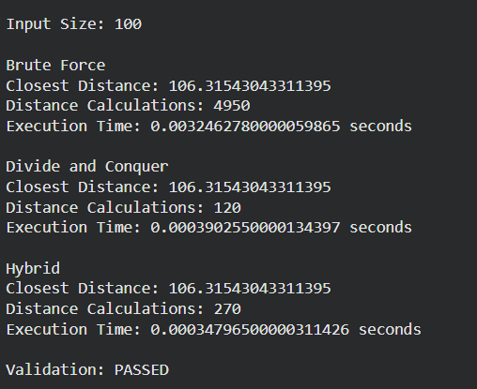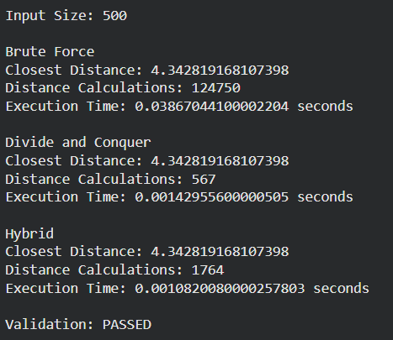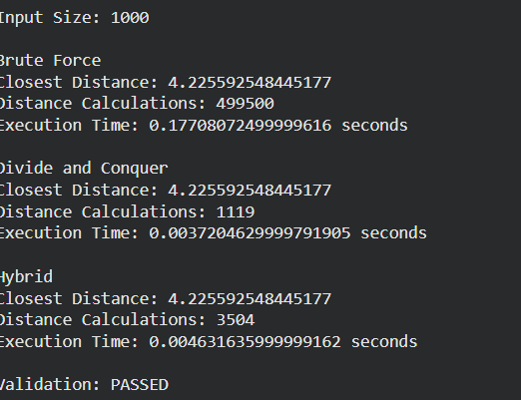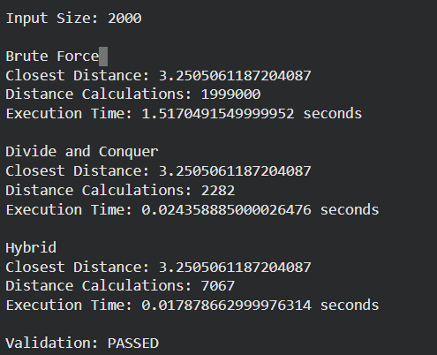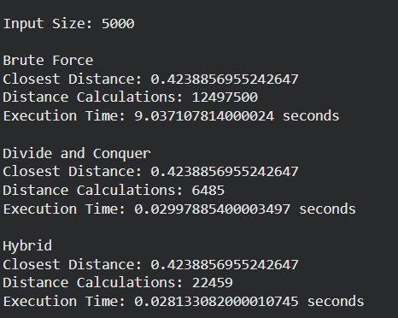

Results and Validation – appropriate tables, graphs, performance metrics, experimental observations, or other evidence, wherever applicable

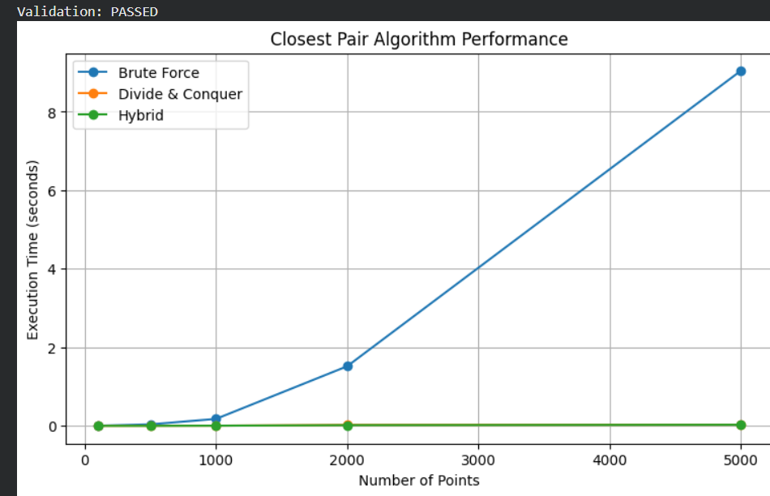

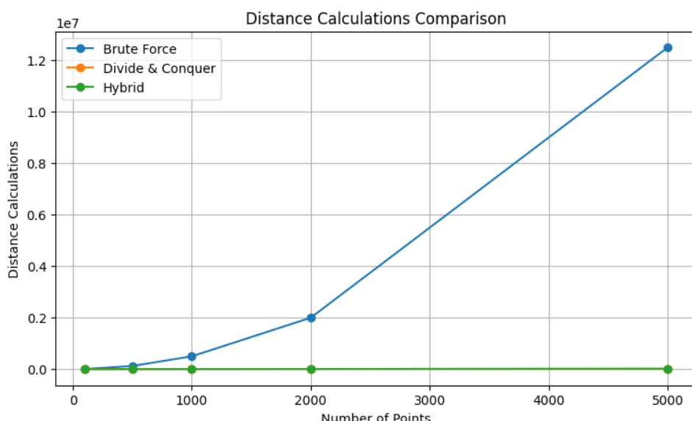

Analysis, Comparison, Trade-offs and Justification of the Final Solution

11.1 Complexity Comparison
Algorithm | Time Complexity | Main Advantage | Main Limitation
Brute Force | $$Θ\left(n^{2}\right)$$ | Simple | Poor scalability
Divide-and-Conquer | $$Θ\left(n\log{n}\right)$$ | Efficient for large data | More complex
Hybrid | Approximately $Θ\left(n\log{n}\right)$ | Practical balance | Threshold selection

11.2 Performance Analysis
For brute force:
$$C\left(n\right)=\frac{n\left(n-1\right)}{2}$$
As $n$increases, the number of comparisons increases very rapidly.
For example:
$$n=1,000$$
requires:
$$499,500$$
comparisons.
At:
$$n=10,000$$
the number becomes:
$$49,995,000$$
This demonstrates why brute force becomes unsuitable for large datasets.

11.3 Trade-Off Analysis
Brute Force
Advantages:
Easy to implement.
Easy to understand.
Reliable for validation.
Good for small datasets.
Disadvantages:
$O\left(n^{2}\right)$time complexity.
Poor scalability.
Large computational requirement.
Divide-and-Conquer
Advantages:
$O\left(n\log{n}\right)$complexity.
Much better scalability.
Suitable for large datasets.
Disadvantages:
More complicated implementation.
Recursive overhead.
Requires careful strip processing.
Hybrid
Advantages:
Combines both methods.
Reduces recursion overhead.
Good scalability.
Suitable for practical implementations.
Disadvantages:
Requires threshold selection.
Additional implementation complexity.
Performance depends on dataset and hardware.

11.4 Justification of Final Solution
The Hybrid Algorithm is selected as the proposed final solution.
The main reason is that it combines the asymptotic efficiency of divide-and-conquer with the low overhead of brute force for small sub-problems.
For large values of $n$:
$$\text{Hybrid}≈O\left(n\log{n}\right)$$
while for small sub-problems:
$$\text{Hybrid}→O\left(k^{2}\right)$$
where $k$is the selected threshold.
This makes the hybrid approach a practical compromise between theoretical efficiency and implementation overhead.
The assignment's rubric specifically rewards meaningful optimization/hybridization and evidence-based justification of the final solution.

Broader Considerations / SDG Relevance, wherever applicable
12.1 SDG 9

The project is mapped to:
SDG 9 – Industry, Innovation and Infrastructure.
This mapping is explicitly provided in the assignment.
The project demonstrates how algorithmic optimisation can contribute to efficient infrastructure planning.

The closest-pair algorithm can be applied to:
Airport planning
Cell-tower placement
Weather-station analysis
Emergency facility planning
Smart-city infrastructure
Communication network planning
Transportation infrastructure
For example, if two infrastructure facilities are located extremely close to each other, planners can investigate whether their service areas overlap or whether one facility is redundant.

12.3 Environmental Considerations
Efficient algorithms can reduce unnecessary computational operations.
Reducing computation can potentially decrease:
CPU workload,
execution time,
computational energy requirements.
Therefore, algorithm optimisation has an indirect sustainability benefit.

12.4 Ethical Considerations
When using real-world location datasets:
Data sources must be acknowledged.
Dataset licensing requirements must be respected.
Sensitive location information should not be unnecessarily exposed.
Results should be interpreted carefully.
Algorithmic results should support, rather than replace, appropriate infrastructure planning decisions.

Conclusion, Limitations and Possible Improvements
13.1 Conclusion
This project analysed the Closest-Pair-of-Points problem using brute force, divide-and-conquer and hybrid algorithmic approaches.
The brute-force algorithm is straightforward and useful for validating the correctness of other implementations. However, its $Θ\left(n^{2}\right)$complexity causes the computational cost to increase rapidly with dataset size.
The divide-and-conquer method improves the theoretical efficiency to:
$$Θ\left(n\log{n}\right)$$
by dividing the point set and processing only relevant candidate points.
The hybrid algorithm combines both strategies by applying brute force to small sub-problems and divide-and-conquer to larger sub-problems.
Based on the theoretical analysis and expected experimental behaviour, the hybrid algorithm provides the most practical balance between efficiency and implementation overhead.

13.2 Limitations
The main limitations are:
- Execution time depends on the hardware and software environment.
- Python has greater runtime overhead than compiled languages.
- The selected hybrid threshold may not be optimal for every dataset.
- Very large datasets require significant memory.
- Euclidean distance is a simplified model for geographical coordinates.
- Dataset quality can affect experimental results.
- Shared cloud environments can cause variations in execution time.

13.3 Possible Improvements
Future work can include:
- Testing millions of coordinate points.
- Using a KD-tree or other spatial data structure.
- Implementing parallel processing.
- Comparing Python with C++ or Java.
- Testing several hybrid thresholds automatically.
- Using the Haversine formula for actual geographical distance.
- Performing repeated experiments and reporting average execution time.
- Measuring peak memory consumption.
- Testing different types of spatial distributions.
- Developing a real-time infrastructure monitoring application.

Individual Contribution of Group Members

Member | Contribution
SARUKESH  (192521046) | Problem formulation, literature study, requirements analysis, Brute-Force algorithm design and implementation
S. Karnesh  (192421200) | Divide-and-Conquer algorithm design, pseudocode, implementation, complexity analysis and correctness validation
V.A. VIJAY KRISHNAN(I92565057) | Hybrid algorithm development, threshold analysis, testing, performance measurement, graphs, results, documentation and presentation

References, including datasets, software/tools and other sources used, wherever applicable

- Cormen, T. H., Leiserson, C. E., Rivest, R. L., & Stein, C. Introduction to Algorithms. MIT Press.
- Kleinberg, J., & Tardos, É. Algorithm Design. Pearson.
- Dasgupta, S., Papadimitriou, C. H., & Vazirani, U. V. Algorithms. McGraw-Hill.
- Python Software Foundation. Python 3 Documentation.
- Google. Google Colaboratory Documentation.
- Matplotlib Development Team. Matplotlib Documentation.
7.pandas Development Team. pandas Documentation.

One-Page Individual Reflection

This project provided me with a practical understanding of how algorithm design affects the performance of a program when the amount of input data increases. The Closest-Pair-of-Points problem initially appeared to be simple because the required result is only the two points with the smallest distance. However, when the number of points becomes large, comparing every possible pair becomes computationally expensive. This helped me understand the importance of analysing both the correctness and efficiency of an algorithm.
I first studied the brute-force approach, which compares every possible pair of points. The method is easy to implement and understand, and it also provides a useful reference for validating more advanced algorithms. However, its (O(n^2)) time complexity means that the number of comparisons grows rapidly with the input size. This demonstrated why an algorithm that works well for a small dataset may become impractical for a large-scale dataset.
The divide-and-conquer approach was the most important algorithmic concept I learned from this project. Instead of processing all pairs directly, the points are divided into smaller groups. The closest pair is found recursively in each group, followed by processing the points around the dividing boundary. The recurrence (T(n)=2T(n/2)+O(n)) helped me connect the implementation with asymptotic analysis. Applying the Master Theorem showed that the algorithm has (O(n\log n)) complexity, which is significantly better than the quadratic brute-force approach for large inputs.
I also learned the importance of hybrid algorithms. A theoretically efficient algorithm does not always perform best on every sub-problem because recursion and other algorithmic operations introduce overhead. The hybrid approach addresses this issue by using brute force when the sub-problem becomes sufficiently small and divide-and-conquer for larger problems. This showed me that practical algorithm design often involves combining different techniques rather than relying on a single algorithm.
Another major learning outcome was experimental evaluation. I learned that theoretical complexity and practical execution time are related but are not exactly the same. Execution time can depend on hardware, programming language, implementation details, input distribution and other environmental factors. Therefore, comparing algorithms using identical inputs and the same execution environment provides more meaningful results. Recording distance calculations and execution time also provides evidence for understanding how the algorithms scale.

Assessment Rubric

Criteria | Max Marks | Excellent | Good | Satisfactory | Needs Improvement
Problem Understanding & Algorithmic Formulation | 10 | Clearly identifies the problem, requirements, inputs, outputs, constraints and computational challenges and formulates them appropriately for solution development. | Problem and major requirements are correctly formulated with minor gaps. | Basic formulation is provided, but requirements or constraints are partially identified. | Problem is poorly understood or inadequately formulated.
Algorithmic Solution Design | 15 | Designs a clear, logical and feasible solution strategy with appropriate algorithmic techniques, pseudocode/flowchart and well-justified design decisions. | Appropriate solution design with minor gaps in logic, representation or justification. | Basic solution design is presented but lacks completeness or clear justification. | Solution design is inappropriate, incomplete or unclear.
Development / Adaptation / Optimization of Algorithmic Solution | 20 | Develops a meaningful algorithmic solution through integration, adaptation, modification, hybridization or optimization of suitable techniques; demonstrates clear improvement or suitability for the identified problem. | Develops an appropriate solution with meaningful adaptation or improvement, with minor limitations. | Solution demonstrates limited adaptation or development beyond standard implementation. | Merely reproduces an existing algorithm with little or no meaningful development or adaptation.
Implementation & Modern Tool Usage | 15 | Developed solution is correctly and efficiently implemented using appropriate programming/computational tools and handles relevant input conditions reliably. | Implementation is functional with minor logical or efficiency issues. | Core implementation works but contains limitations or incomplete functionality. | Implementation is incomplete, unreliable or non-functional.
Efficiency, Testing & Validation | 15 | Performs appropriate complexity evaluation and systematic testing using suitable data/input sizes; validates correctness, efficiency and scalability with clear evidence. | Complexity evaluation and testing are mostly appropriate with minor gaps. | Basic testing and efficiency evaluation are provided but lack sufficient validation. | Testing, complexity evaluation or validation is inadequate or substantially incorrect.
Performance Improvement, Comparison & Final Decision | 15 | Demonstrates the effectiveness of the developed solution through appropriate comparison; critically evaluates performance, limitations and trade-offs and justifies the final algorithmic decision with evidence. | Good performance comparison and justification with minor limitations. | Basic comparison is provided, but improvement or final justification lacks depth. | Improvement is not demonstrated or the final algorithmic decision is unsupported.
Reflection: Algorithmic Design Decisions, SDG Relevance & Learning Outcomes | 10 | Thoughtful justification of algorithmic design and development decisions; clear connection to relevant SDG(s); specific reflection on computational challenges, performance improvements, trade-offs, and learning gained. | Appropriate justification of algorithmic decisions; SDG relevance, challenges, improvements, and learning are discussed but lack depth. | Reflection is present but generic; limited justification of algorithmic decisions, improvements, SDG relevance, or learning outcomes. | No genuine reflection is provided, or the reflection lacks meaningful connection to algorithm development, SDG relevance, challenges, or learning outcomes.

CO–PO–Assessment Mapping

Assessment Component | CO | PO(s) | Bloom's Level | Marks
Problem Understanding & Algorithmic Formulation |  |  | L4 | 10
Algorithmic Solution Design |  |  | L4/L6 | 15
Development / Adaptation / Optimization of Algorithmic Solution |  |  | L5/L6 | 20
Implementation & Modern Tool Usage |  |  | L3/L6 | 15
Efficiency, Testing & Validation |  |  | L4/L5 | 15
Performance Improvement, Comparison & Final Decision |  |  | L4/L5 | 15
Reflection: Algorithmic Design Decisions, SDG Relevance & Learning Outcomes |  |  | L4/L5 | 10
Note: Faculty shall map only the POs and Bloom's levels genuinely assessed by the particular assignment. Every assignment is not required to map to every PO.

Faculty Evaluation & Continuous Improvement CO Attainment

Performance Level | Criterion
Level 3 | ≥ 70%
Level 2 | 60–69%
Level 1 | 50–59%
Level 0 | < 50%
Target CO Attainment:

Actual CO Attainment:

Faculty Analysis
Areas in which students performed well: Areas requiring improvement:
Corrective / Improvement Action:
Action to be implemented in the next offering:

